**NAYAN MUKHEREE**

**CA_BOOTCAMP2020_DAY2**

**TASK: 01**

**Create directories which would have the following structure by using only mkdir command:**

**HIERARCHY:**

consultadd/

|-- Python

| `-- Django

| `-- restframework

|-- java

| `-- springboot

|-- javascript

| `-- angular

| `-- react

|-- SQL

| `-- mysql

`-- bootcamp

**Answer:**

$ mkdir -p consultadd/{Python/Django/restframework,Java/springboot,Javascript/{angular,react},SQL/mysql,bootcamp}

**TASK 02:**

● Create Directory called consultadd

● Inside that create 5 more directories named them as dir1, dir2, dir3, dir4 and dir5

● What would be the output of Long Listing after creating these directories?

● List all the directories with ls and echo * and see the difference.

● Create a 2 files named them file1.txt and file2.txt inside dir3

● Move dir5 into the dir3

● Remove dir 3 after moving all files from dir3 to dir2.

● Go to the dir2 and create one more file with name index.html

● Move to top-level directory

● Check the permission of all files and directory from current place make sure when you do **pwd** it should be on consultadd

● Rename all files of dir2 with extension of .txt to .py

**Answer:**

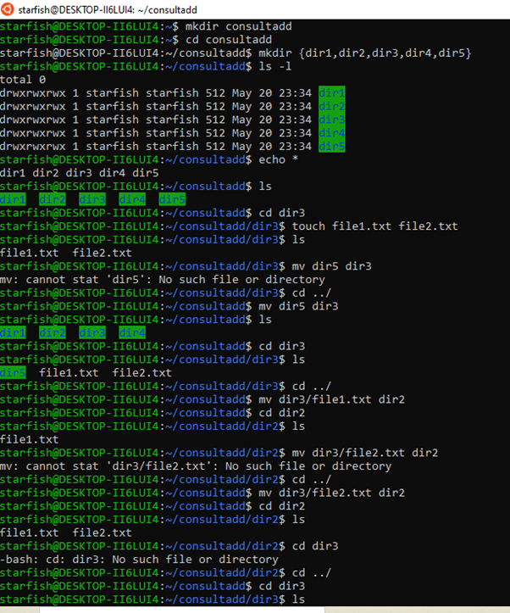

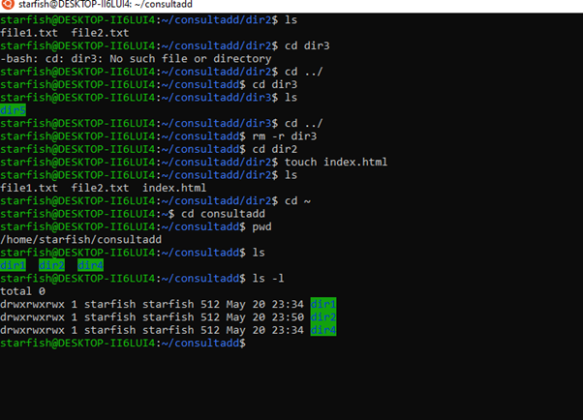

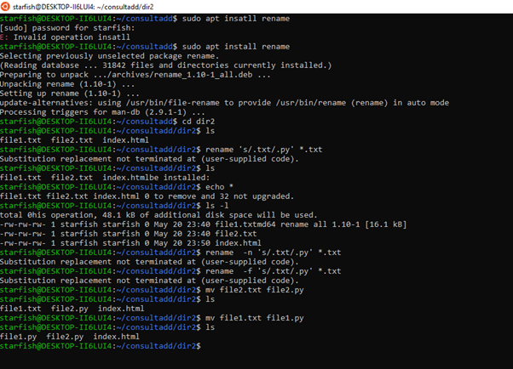

**TASK: 03**

● What is Nano Editor?

**Answer:**

GNU nano is a text editor for Unix-like computing systems or operating environments using a command-line interface. It emulates the Pico text editor, part of the Pine email client, and also provides additional functionality. Unlike Pico, nano is licensed under the GNU General Public License.

○ How to create a sample file in Nano Editor?

**Answer:**

If you want to create a new file and open it using nano, then you can do this by running the following command:

*$ nano*

or

*$ nano [file-name]*

The second way can also be used to open an existing file.

○ How to save a file?

**Answer:**

If you want to **save** the changes you've made, press Ctrl + O. To exit **nano**, type Ctrl + X. If you ask **nano** to exit from a modified **file**, it will ask you if you want to **save** it. Just press N in case you don't, or Y in case you do.

● What is Vi Editor?

**Answer:**

The default **editor** that comes with the UNIX operating system is called **vi** (visual **editor**). Using **vi editor**, we can edit an existing file or create a new file from scratch. we can also use this **editor** to just read a text file. Command Mode: When **vi** starts up, it is in Command Mode.

○ Operation in Vi Editor

**Answer:**

While working with the vi editor, we usually come across the following two modes −

* Command mode − This mode enables you to perform administrative tasks such as saving the files, executing the commands, moving the cursor, cutting, and pasting the lines or words, as well as finding and replacing. In this mode, whatever you type is interpreted as a command.
* Insert mode − This mode enables you to insert text into the file. Everything that's typed in this mode is interpreted as input and placed in the file.

vi always starts in the command mode. To enter text, you must be in the insert mode for which simply type i. To come out of the insert mode, press the Esc key, which will take you back to the command mode.

**TASK: 04**

● Type **finger** to see your account and name.

● Type **cal** to see this month’s calendar.

● Create a file and give a name random.txt to it with content into it which says “Hello Welcome to the Consultadd Inc Bootcamp”.

● Display the same content using **cat** command.

**Answer:**

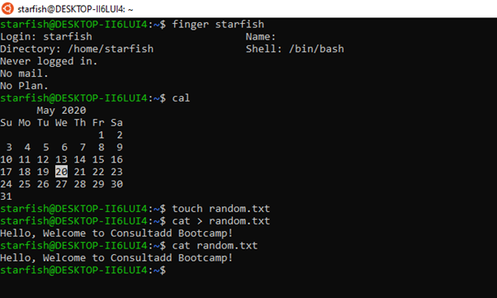

**TASK: 05**

**●** Explain the workflow of the Internet in one paragraph.

**Answer:**

Computer A sends message to Computer B's IP Address. The message is broken into smaller pieces called Packets. Packets are sent along the Packet Routing Network to correct IP addresses. Packets are subject to Transfer Control Protocol to maintain quality. Packets are received and reassembled at Computer B's IP Address.

● How LAN is different from the WAN network?

Answer:

A LAN, abbreviated from Local Area Network, is a network that covers a small geographical area such as homes, offices, and groups of buildings. Whereas a WAN, abbreviated from Wide Area Network, is a network that covers larger geographical areas which can span the globe. An example of a widely used WAN is the Internet, which is a collection of tens of thousands of networks that connects tens of billions of devices.